Welcome To
Trinity Lutheran Church
Lutheran Church—Missouri Synod
A Stephen Ministry Congregation

1354 South Otsego Avenue
Gaylord, Michigan 49735
Church Phone: (989) 732-4816

Church Email: secretary@trinitygaylord.com
www.trinitygaylord.com

Office Hours: Monday through Friday 9am – 1pm

OUR PURPOSE
…is to LOVE GOD, LOVE OTHERS, AND SERVE THE WORLD by worshiping the Lord Jesus, bringing our members into Christ-like maturity, and equipping them through Word and Sacrament for their mission and ministry. We go heart to heart into the world with Jesus, sharing His love, caring for one another, praying, and bringing the lost into a relationship with Christ, by the working of the Holy Spirit.

November 20, 2022
Last Sunday of the Church Year
Preacher: Rev. Paul Schneider

ABOUT OUR WORSHIP
We welcome all who gather here today! We are blessed to celebrate together the mercy, grace, and love we have from God through the death and resurrection of our Lord Jesus Christ.

Children: Families with children are very welcome here. Having children in church is important so they can begin to learn about their faith in Jesus, and it’s good for the whole congregation to see. Please feel comfortable keeping “squirmy” kids in the service. This is where they belong, too!

Pew Cards: Guests and Members, please fill out the Guest/Member card located on the back of the pew in front of you and pass it to the end of the aisle. If you forget you can put it in the offering plate on your way out.

If standing is difficult: Please feel free to remain seated during any portion of the service. Please let an Elder or Usher know if you need communion in your pew seat.

About our celebration of Holy Communion: We celebrate the Lord’s Supper in the confession and glad confidence that, as he says, our Lord gives into our mouths not only bread and wine but his very body and blood to eat and to drink for the forgiveness of sins and to strengthen our union with him and with one another. Our Lord invites to his table those who trust his words, repent of all sin, and set aside any refusal to forgive and love as he forgives and loves us, that they may show forth his death until he comes.
Because those who eat and drink our Lord’s body and blood contrary to that which is stated above do so to their great harm, and also because Holy Communion is a confession of the faith which is confessed at this altar. Anyone who is not yet instructed, in doubt, or who hold a confession differing from that of the Lutheran Church—Missouri Synod, and yet desire to receive the sacrament, are asked first to speak with Pastor. Those not communing are still invited to come forward for a blessing from Pastor, and you may indicate this by crossing your arms over your chest.
TTTTTT
GREETING
P Peace be with you.
C And also with you.
P Let us Pray.
T ORDER OF SERVICE T
(The liturgy is from Divine Service Setting four LSB pg. 203ff)

OPENING HYMN
Faith and Truth and Life Bestowing LSB 584
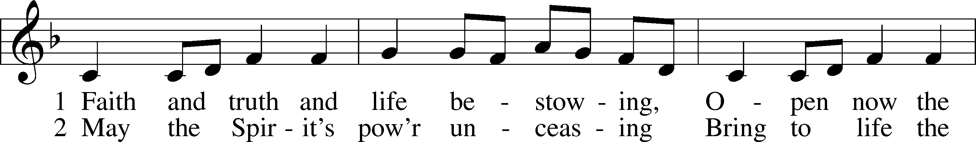
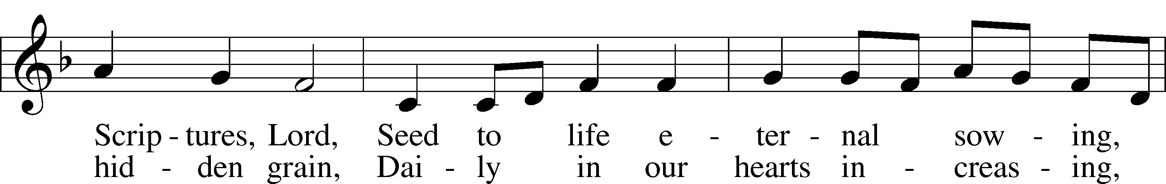
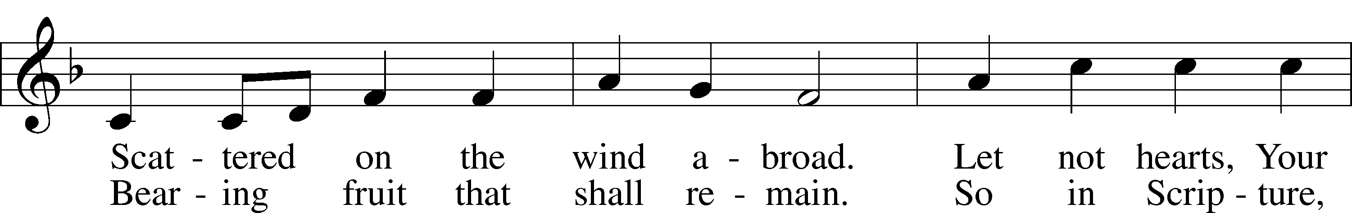
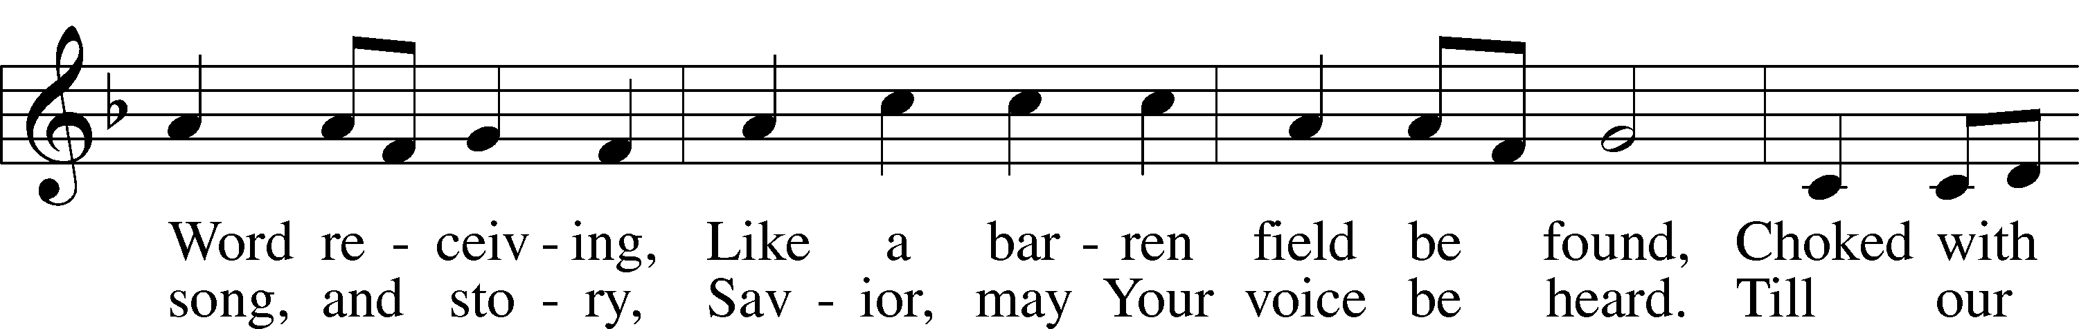
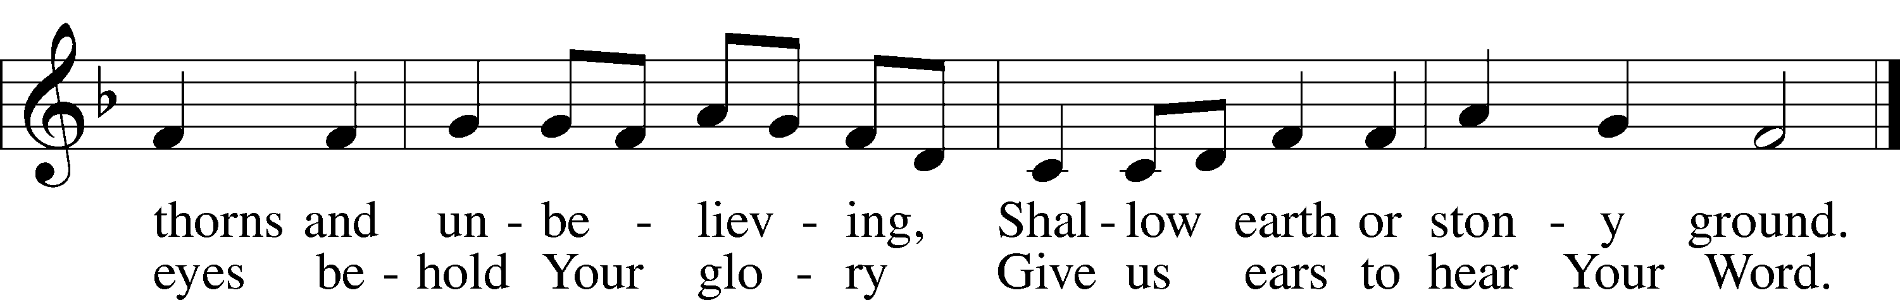

Please stand as able

CONFESSION and ABSOLUTION
The sign of the cross may be made by all in remembrance of their Baptism.

P In the name of the Father and of the T Son and of the Holy Spirit.
C Amen.

P Our help is in the name of the Lord,
C who made heaven and earth.

P If You, O Lord, kept a record of sins, O Lord, who could stand?
C But with You there is forgiveness; therefore You are feared.

P Since we are gathered to hear God’s Word, call upon Him in prayer and praise, and receive the body and blood of our Lord Jesus Christ in the fellowship of this altar, let us first consider our unworthiness and confess before God and one another that we have sinned in thought, word, and deed, and that we cannot free ourselves from our sinful condition. Together as His people let us take refuge in the infinite mercy of God, our heavenly Father, seeking His grace for the sake of Christ, and saying: God, be merciful to me, a sinner.

C Almighty God, have mercy upon us, forgive us our sins, and lead us to everlasting life. Amen.

P Almighty God, merciful Father, in Holy Baptism You declared us to be Your children and gathered us into Your one, holy Church, in which You daily and richly forgive us our sins and grant us new life through Your Spirit. Be in our midst, enliven our faith, and graciously receive our prayer and praise; through Your Son, Jesus Christ, our Lord.
C Amen.
T SERVICE OF THE WORD T
KYRIE
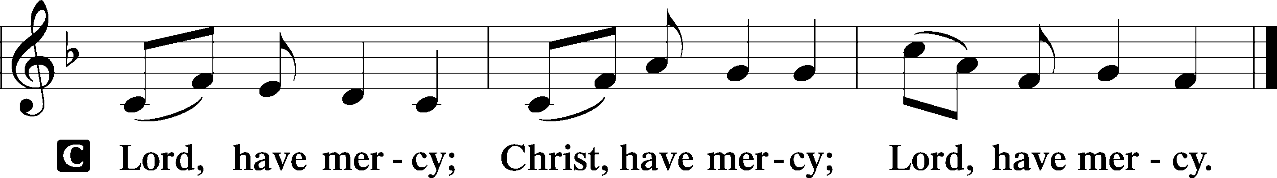

HYMN OF PRAISE
GLORIA IN EXCELSIS LSB 204
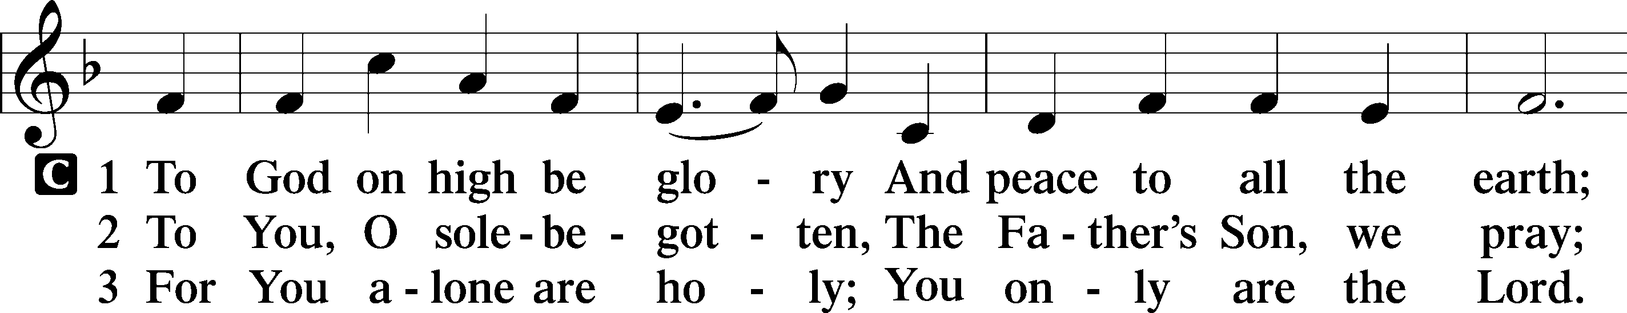
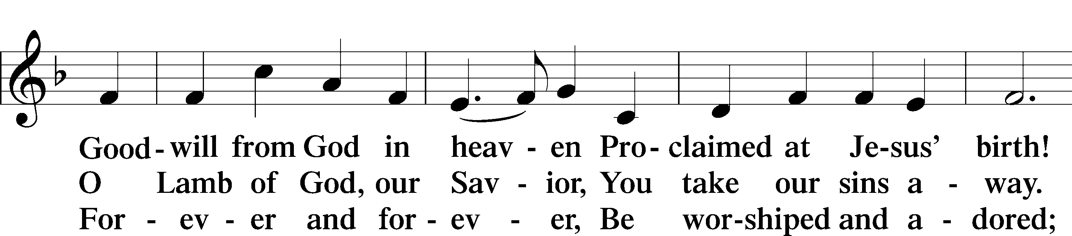
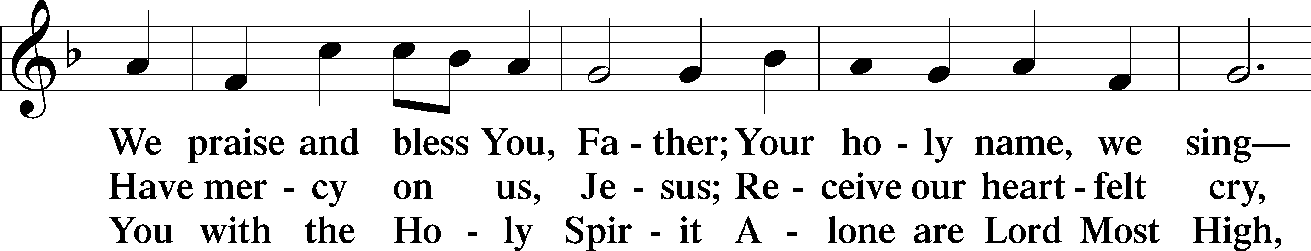
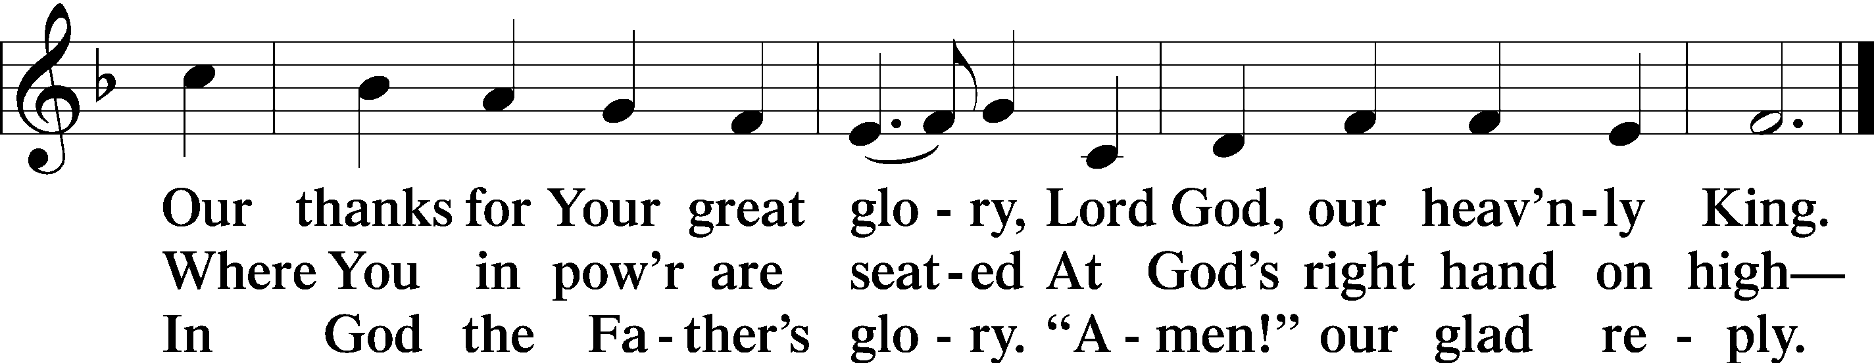

SALUTATION AND COLLECT OF THE DAY
P The Lord be with you.
C And also with you.
P Let us pray.
Lord Jesus Christ, You reign among us by the preaching of Your cross. Forgive Your people their offenses that we, being governed by Your bountiful goodness, may enter at last into Your eternal paradise; for You live and reign with the Father and the Holy Spirit, one God, now and forever.
C Amen.

Pleases be seated

FIRST READING Malachi 3:13–18
¹³“Your words have been hard against me, says the Lord. But you say, ‘How have we spoken against you?’ ¹⁴You have said, ‘It is vain to serve God. What is the profit of our keeping his charge or of walking as in mourning before the Lord of hosts? ¹⁵And now we call the arrogant blessed. Evildoers not only prosper but they put God to the test and they escape.’”
¹⁶Then those who feared the Lord spoke with one another. The Lord paid attention and heard them, and a book of remembrance was written before him of those who feared the Lord and esteemed his name. ¹⁷“They shall be mine, says the Lord of hosts, in the day when I make up my treasured possession, and I will spare them as a man spares his son who serves him. ¹⁸Then once more you shall see the distinction between the righteous and the wicked, between one who serves God and one who does not serve him.”

P This is the Word of the Lord.
C Thanks be to God.

EPISTLE Colossians 1:13–20
¹³He has delivered us from the domain of darkness and transferred us to the kingdom of his beloved Son, ¹⁴in whom we have redemption, the forgiveness of sins.
¹⁵He is the image of the invisible God, the firstborn of all creation. ¹⁶For by him all things were created, in heaven and on earth, visible and invisible, whether thrones or dominions or rulers or authorities—all things were created through him and for him. ¹⁷And he is before all things, and in him all things hold together. ¹⁸And he is the head of the body, the church. He is the beginning, the firstborn from the dead, that in everything he might be preeminent. ¹⁹For in him all the fullness of God was pleased to dwell, ²⁰and through him to reconcile to himself all things, whether on earth or in heaven, making peace by the blood of his cross.

P This is the Word of the Lord.
C Thanks be to God.

Please stand as able

ALLELUIA AND VERSE
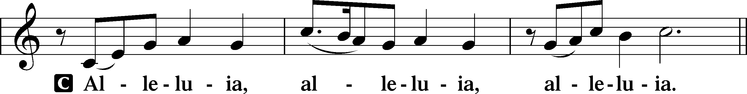
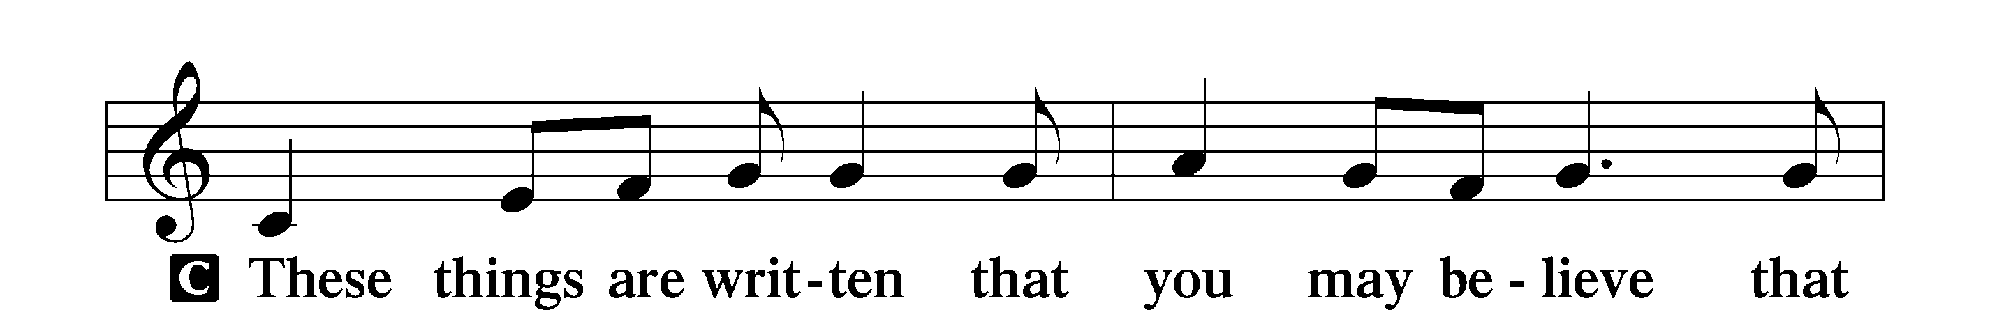
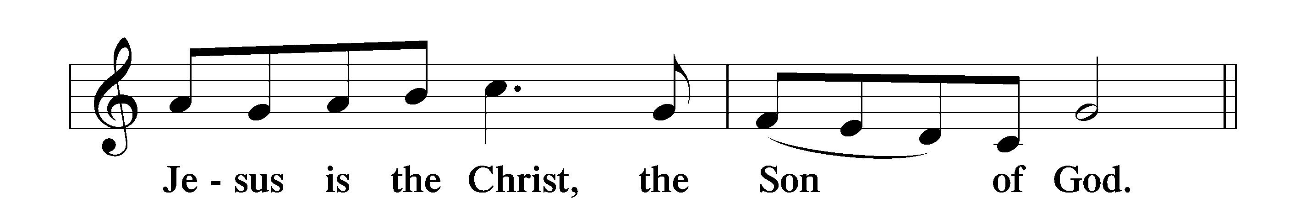
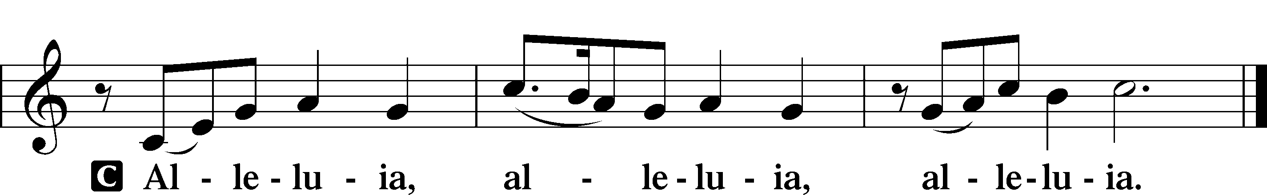

HOLY GOSPEL Luke 23:27–43
P The Holy Gospel according to St. Luke, the twenty-third chapter.
C Glory to You, O Lord.

²⁷And there followed [Jesus] a great multitude of the people and of women who were mourning and lamenting for him. ²⁸But turning to them Jesus said, “Daughters of Jerusalem, do not weep for me, but weep for yourselves and for your children. ²⁹For behold, the days are coming when they will say, ‘Blessed are the barren and the wombs that never bore and the breasts that never nursed!’ ³⁰Then they will begin to say to the mountains, ‘Fall on us,’ and to the hills, ‘Cover us.’ ³¹For if they do these things when the wood is green, what will happen when it is dry?”
³²Two others, who were criminals, were led away to be put to death with him. ³³And when they came to the place that is called The Skull, there they crucified him, and the criminals, one on his right and one on his left. ³⁴And Jesus said, “Father, forgive them, for they know not what they do.” And they cast lots to divide his garments. ³⁵And the people stood by, watching, but the rulers scoffed at him, saying, “He saved others; let him save himself, if he is the Christ of God, his Chosen One!” ³⁶The soldiers also mocked him, coming up and offering him sour wine ³⁷and saying, “If you are the King of the Jews, save yourself!” ³⁸There was also an inscription over him, “This is the King of the Jews.”
³⁹One of the criminals who were hanged railed at him, saying, “Are you not the Christ? Save yourself and us!” ⁴⁰But the other rebuked him, saying, “Do you not fear God, since you are under the same sentence of condemnation? ⁴¹And we indeed justly, for we are receiving the due reward of our deeds; but this man has done nothing wrong.” ⁴²And he said, “Jesus, remember me when you come into your kingdom.” ⁴³And he said to him, “Truly, I say to you, today you will be with me in Paradise.”
P This is the Gospel of the Lord.
C Praise to You, O Christ.

NICENE CREED
C I believe in one God,
the Father Almighty,
maker of heaven and earth
and of all things visible and invisible.
And in one Lord Jesus Christ,
the only-begotten Son of God,
begotten of His Father before all worlds,
God of God, Light of Light,
very God of very God,
begotten, not made,
being of one substance with the Father,
by whom all things were made;
who for us men and for our salvation came down from heaven
and was incarnate by the Holy Spirit of the virgin Mary
and was made man;
and was crucified also for us under Pontius Pilate.
He suffered and was buried.
And the third day He rose again according to the Scriptures
and ascended into heaven
and sits at the right hand of the Father.
And He will come again with glory to judge both the living and the dead,
whose kingdom will have no end.
And I believe in the Holy Spirit,
the Lord and giver of life,
who proceeds from the Father and the Son,
who with the Father and the Son together is worshiped and glorified,
who spoke by the prophets.
And I believe in one holy Christian and apostolic Church,
I acknowledge one Baptism for the remission of sins,
and I look for the resurrection of the dead
and the life T of the world to come. Amen.
Please be seated

ALL GOD’S CHILDREN – TALK
PRE-SERMON HYMN
All Depends on Our Possessing LSB 732 sts. 1–4
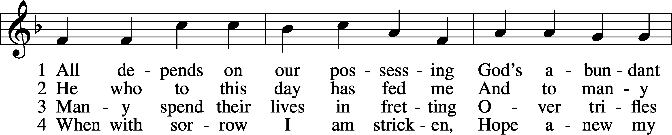
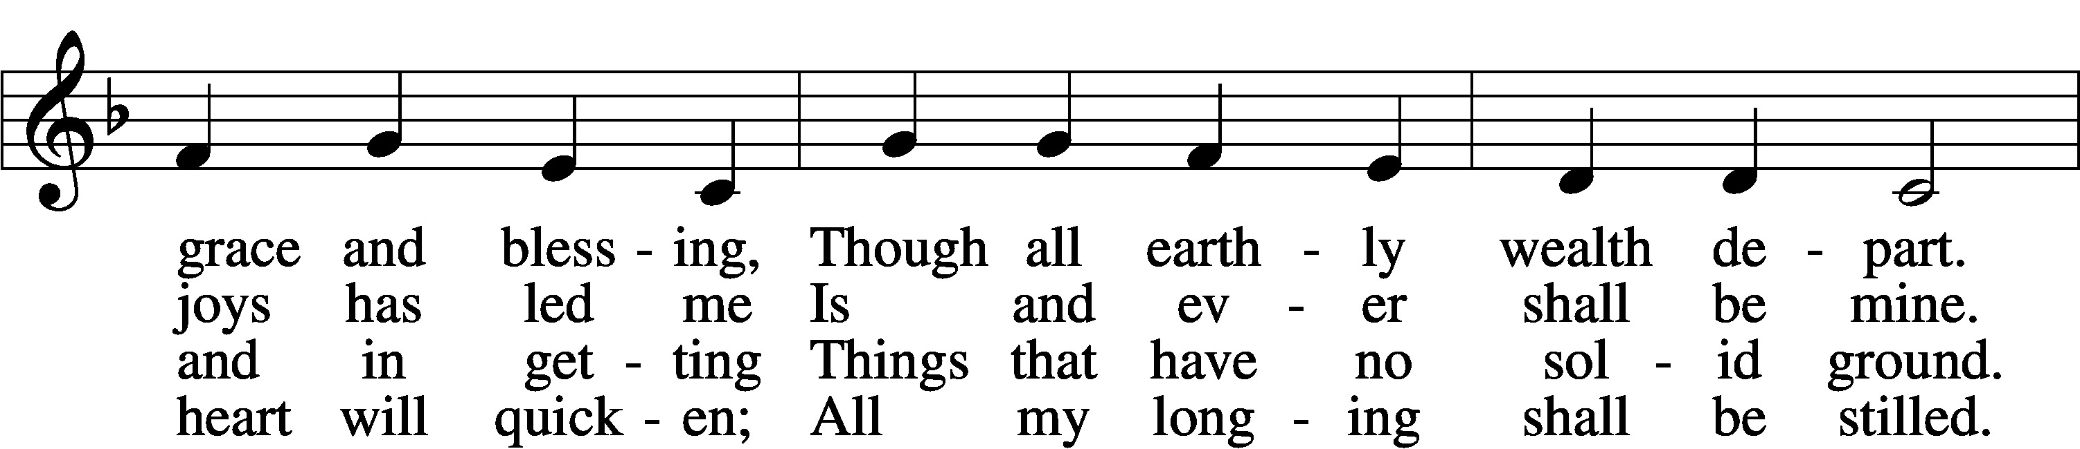
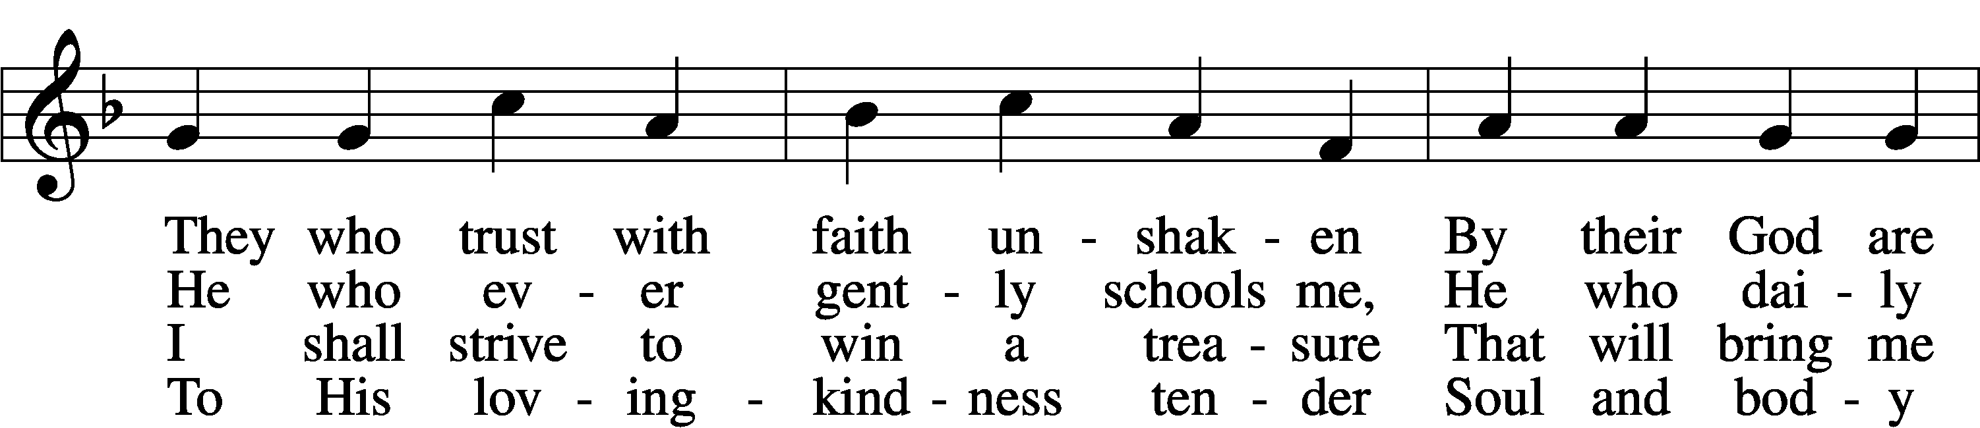
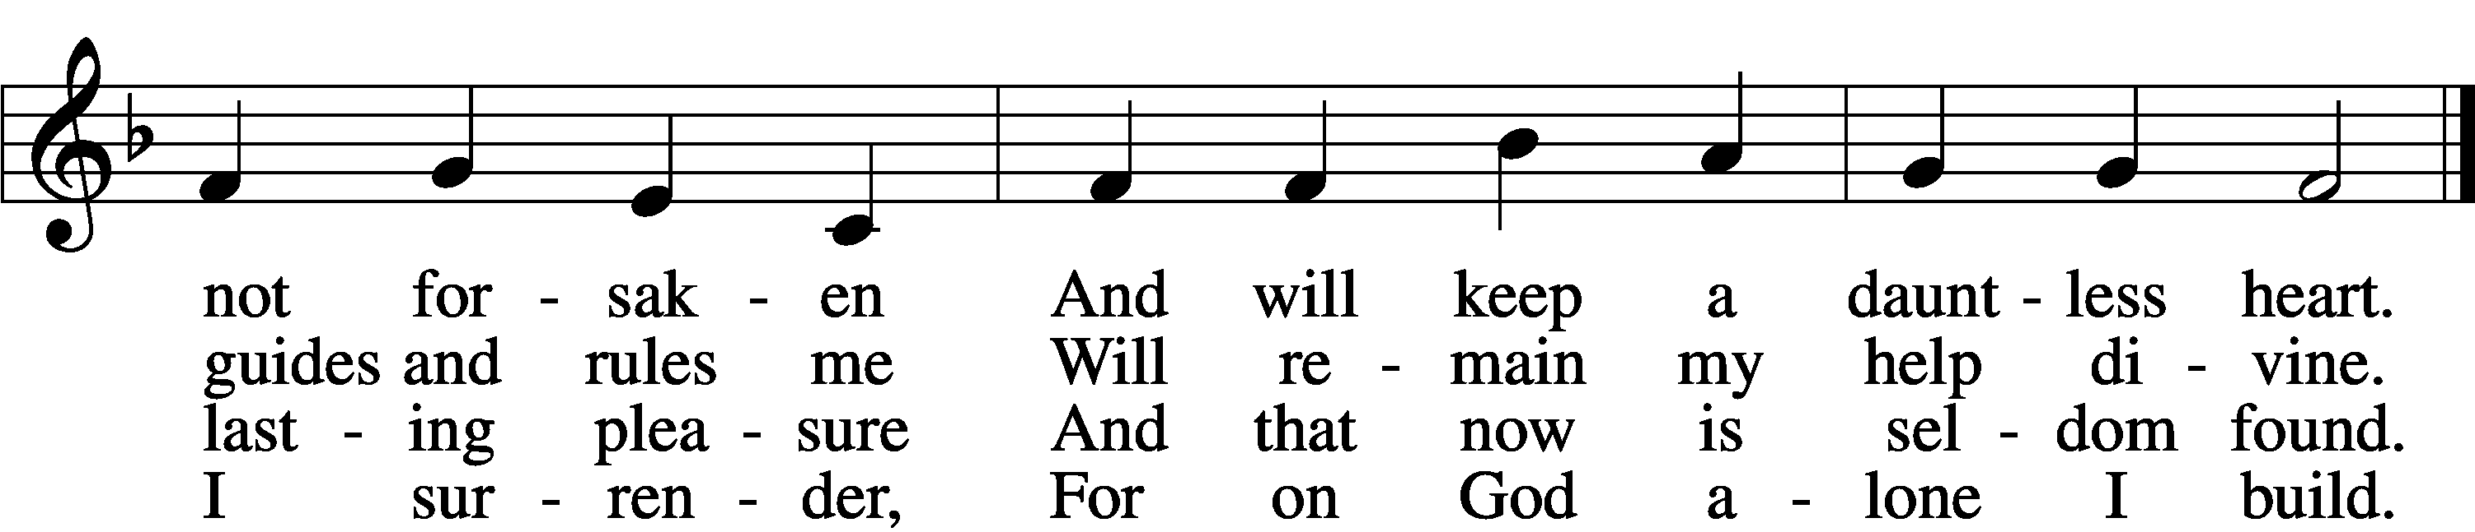

SERMON

POST-SERMON HYMN
All Depends on Our Possessing LSB 732 sts. 5–6
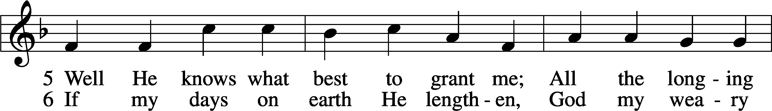
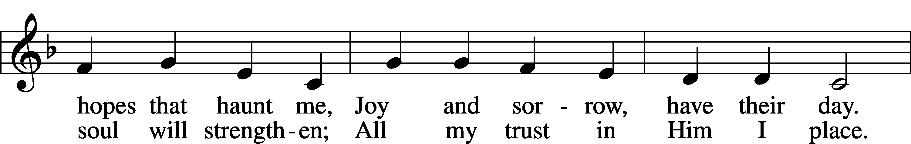
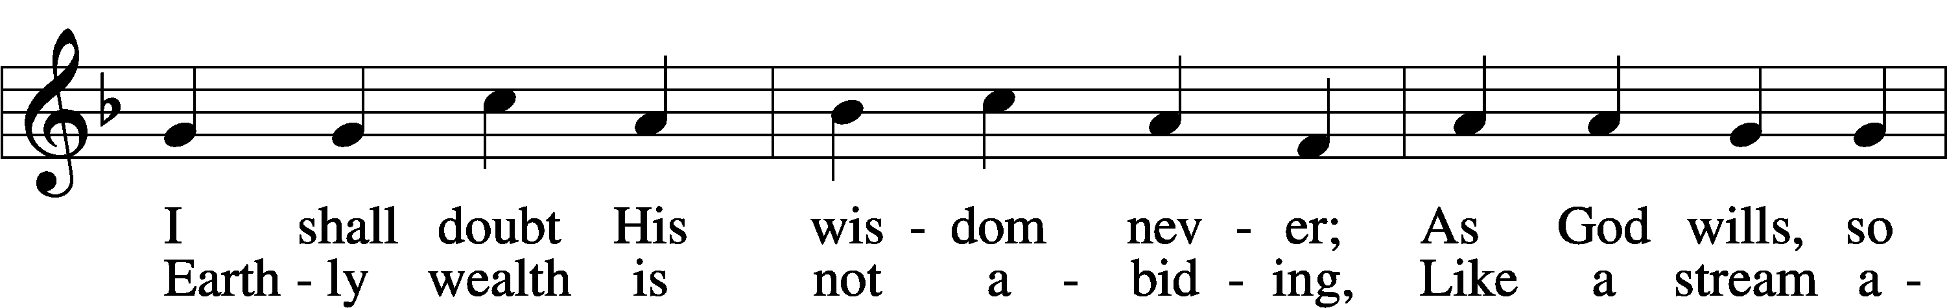
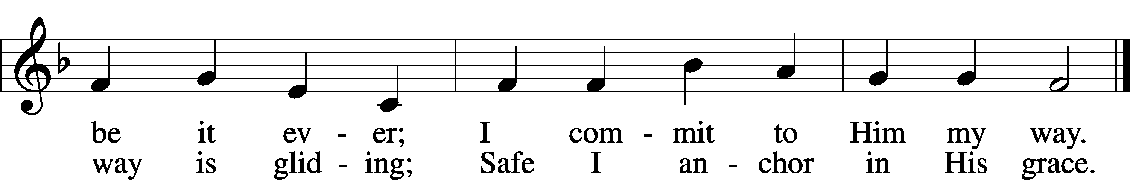

Please stand as able
PRAYER of the CHURCH
After each Segment:
P Lord, in Your Mercy,
C Hear our Prayer.
After Final Segment:
P Hear us as we pray in His name and as He has taught us:

LOR``````D’S PRAYER
C Our Father who art in heaven,
hallowed be Thy name,
Thy kingdom come,
Thy will be done on earth
as it is in heaven;
give us this day our daily bread;
and forgive us our trespasses
as we forgive those
who trespass against us;
and lead us not into temptation,
but deliver us from evil.
For Thine is the kingdom
and the power and the glory
forever and ever. Amen.

T SERVICE of the SACRAMENT T

PREFACE LSB 208
P The Lord be with you.
C And also with you.

P Lift up your hearts.
C We lift them to the Lord.

P Let us give thanks to the Lord our God.
C It is right to give Him thanks and praise.

P It is truly good, right, and salutary that we should at all times and in all places give thanks to You, O Lord, holy Father, almighty and everlasting God, for the countless blessings You so freely bestow on us and all creation. Above all, we give thanks for Your boundless love shown to us when You sent Your only-begotten Son, Jesus Christ, into our flesh and laid on Him our sin, giving Him into death that we might not die eternally. Because He is now risen from the dead and lives and reigns to all eternity, all who believe in Him will overcome sin and death and will rise again to new life. Therefore with angels and archangels and with all the company of heaven we laud and magnify Your glorious name, evermore praising You and singing:
SANCTUS LSB 208
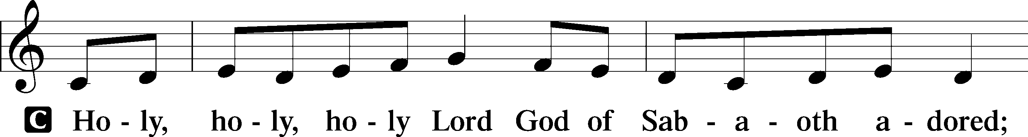
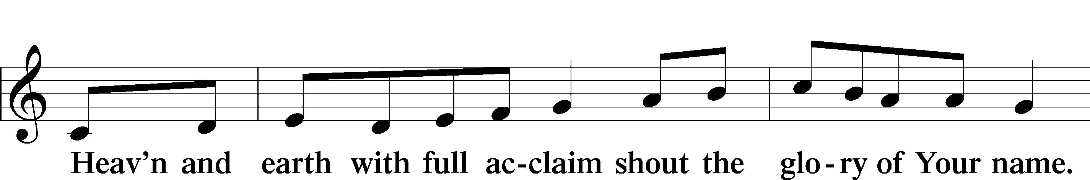
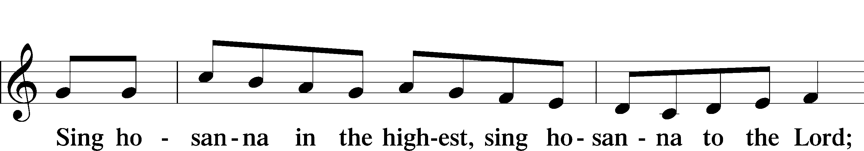
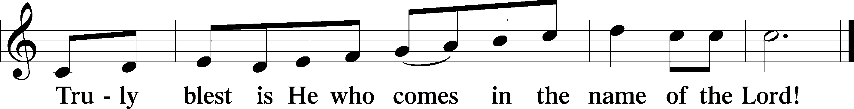

THE WORDS OF OUR LORD
P Our Lord Jesus Christ, on the night when He was betrayed, took bread, and when He had given thanks, He broke it and gave it to the disciples and said: “Take, eat; this is My T body, which is given for you. This do in remembrance of Me.”
In the same way also, He took the cup after supper, and when He had given thanks, He gave it to them, saying: “Drink of it, all of you; this cup is the New Testament in My T blood, which is shed for you for the forgiveness of sins. This do, as often as you drink it, in remembrance of Me.”

PAX DOMINI
P The peace of the Lord be with you always.
C Amen.
AGNUS DEI
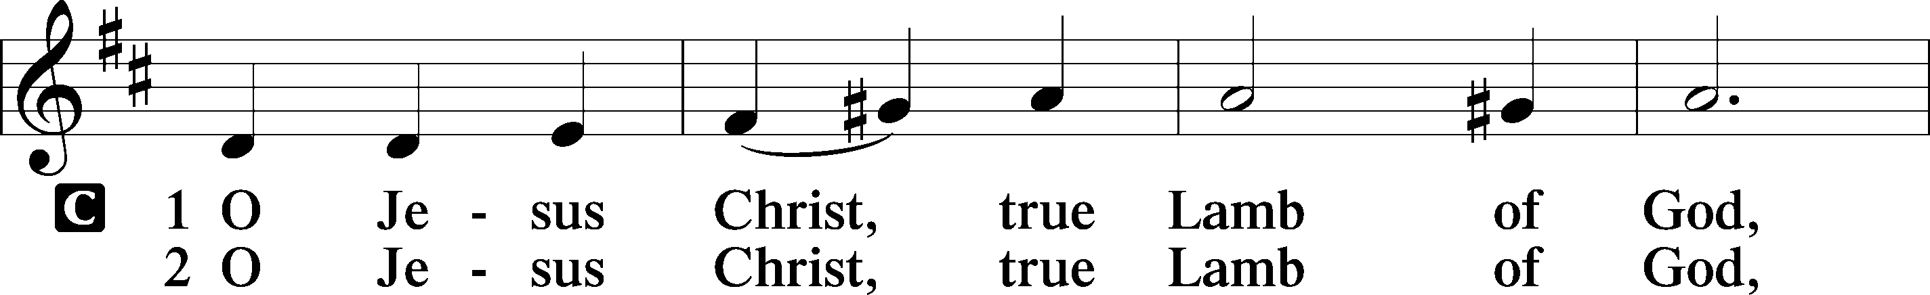
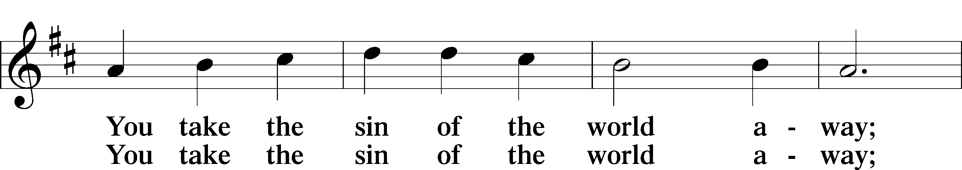
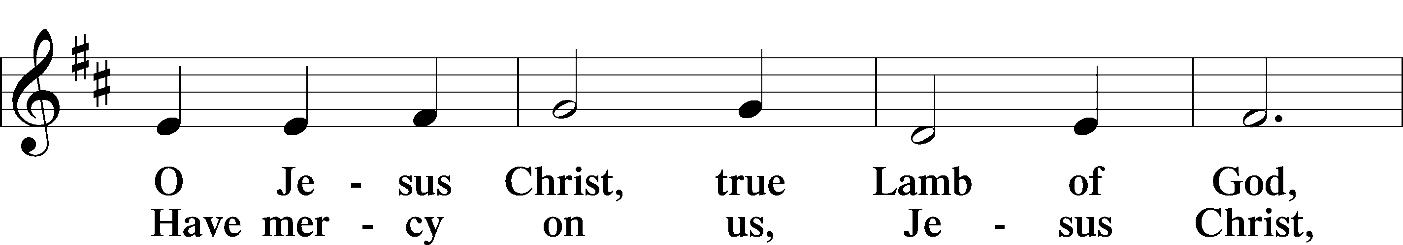
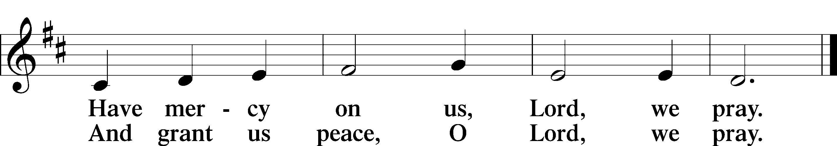

Please be seated
DISTRIBUTION
The pastor and those who assist him receive the body and blood of Christ first, then Communion will be served at the rail. Ushers will help direct you forward via the center aisle; please return to your seats via the side aisles. Gluten-free bread is available for those who need it, as is non-alcoholic grape juice. Simply request either when you come forward to receive Communion.
DISTRIBUTION HYMN
YOUR TABLE I APPROACH LSB 628
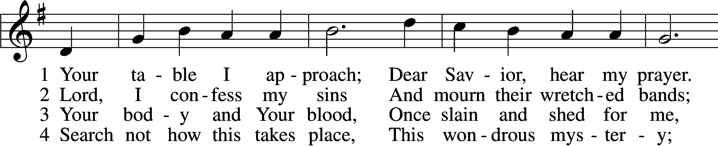
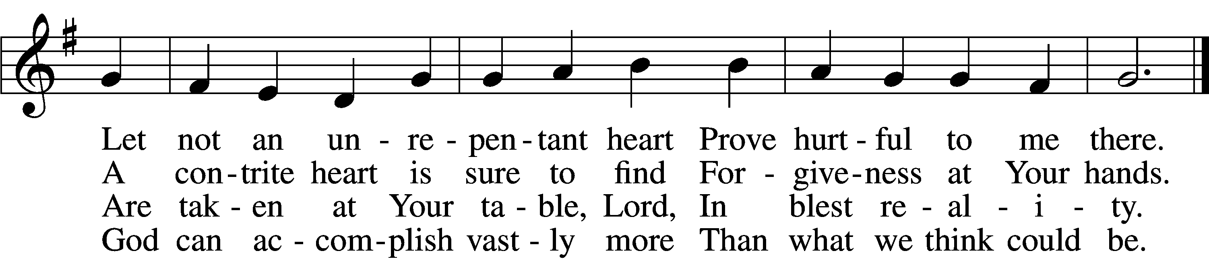
Continued on next page

5 O grant, most blessèd Lord,
That earth and hell combined
May not about this sacrament
Raise doubt within my mind.

6 Oh, may I never fail
To thank You day and night
For Your true body and true blood,
O God, my peace and light.

DISTRIBUTION HYMN
How Sweet the Name of Jesus Sounds LSB 524
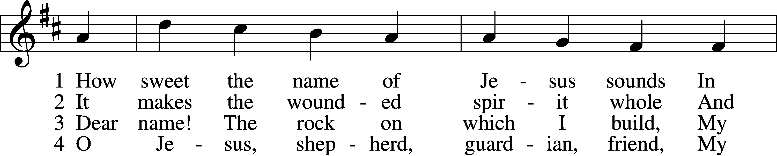
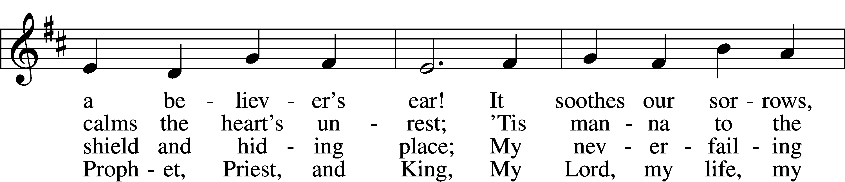
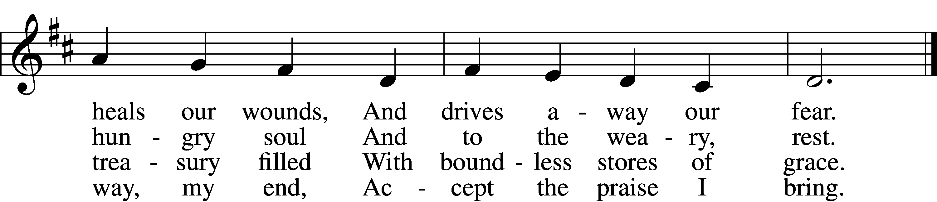

5 How weak the effort of my heart,
How cold my warmest thought!
But when I see Thee as Thou art,
I’ll praise Thee as I ought.

6 Till then I would Thy love proclaim
With ev’ry fleeting breath;
And may the music of Thy name
Refresh my soul in death!

Please stand as able

NUNC DIMITTIS LSB 211
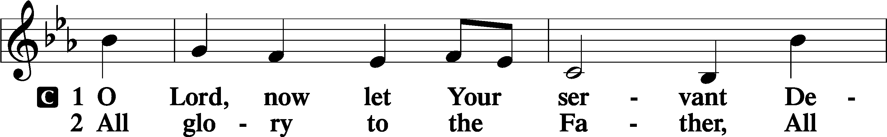
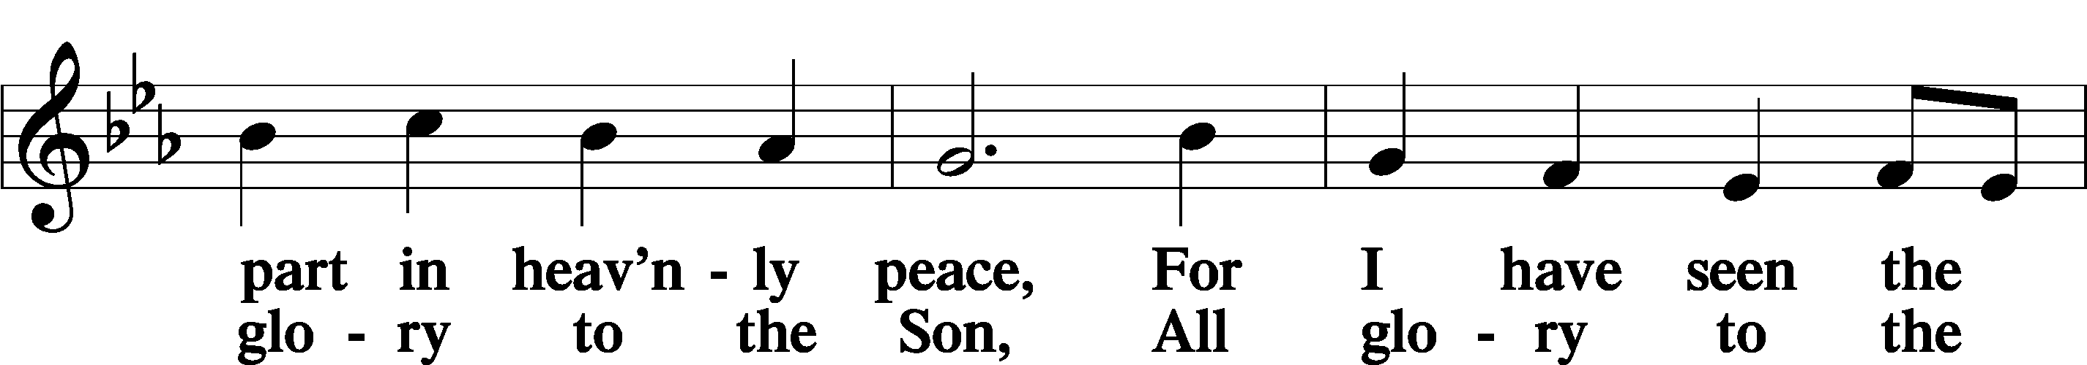
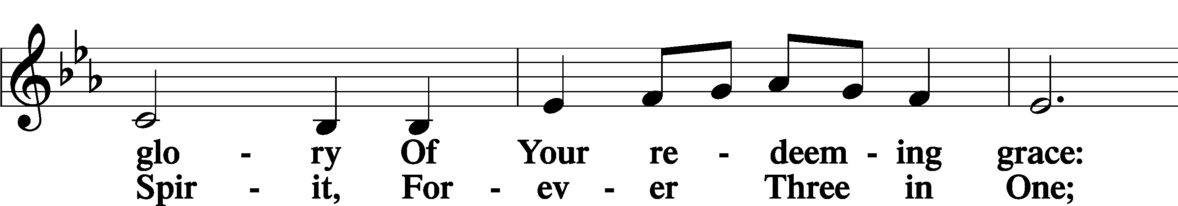
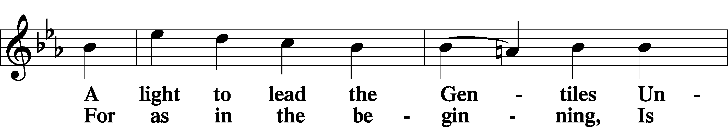
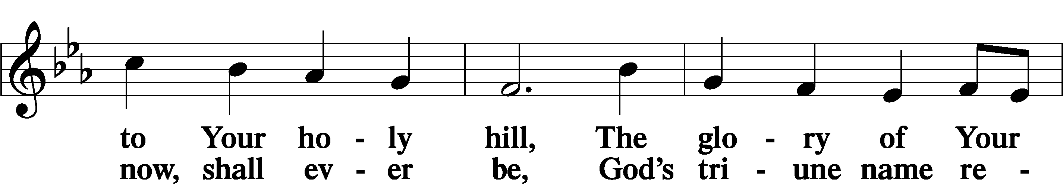
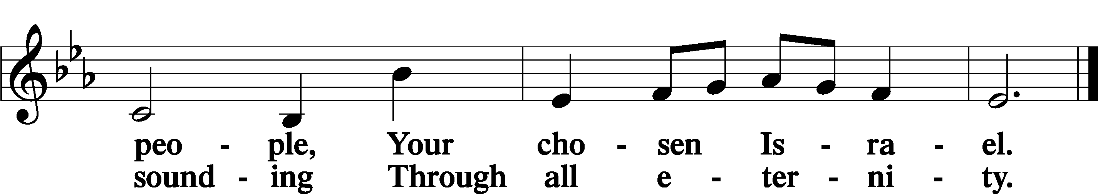

POST COMMUNION COLLECT
P Let us pray.
We give thanks to You, almighty God, that You have refreshed us through this salutary gift, and we implore You that of Your mercy You would strengthen us through the same in faith toward You and in fervent love toward one another; through Jesus Christ, Your Son, our Lord, who lives and reigns with You and the Holy Spirit, one God, now and forever.
C Amen.

BENEDICAMUS LSB 212
P Let us bless the Lord.
C Thanks be to God.

BENEDICTION
P The Lord bless you and keep you.
The Lord make His face shine on you and be gracious to you.
The Lord look upon you with favor and T give you peace.
C Amen.

Please be seated

CLOSING HYMN
Almighty God, Your Word Is Cast LSB 577
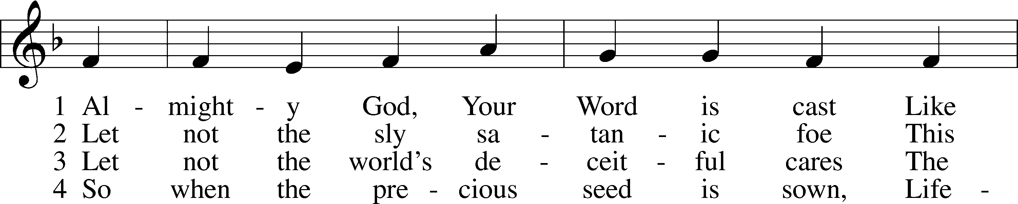
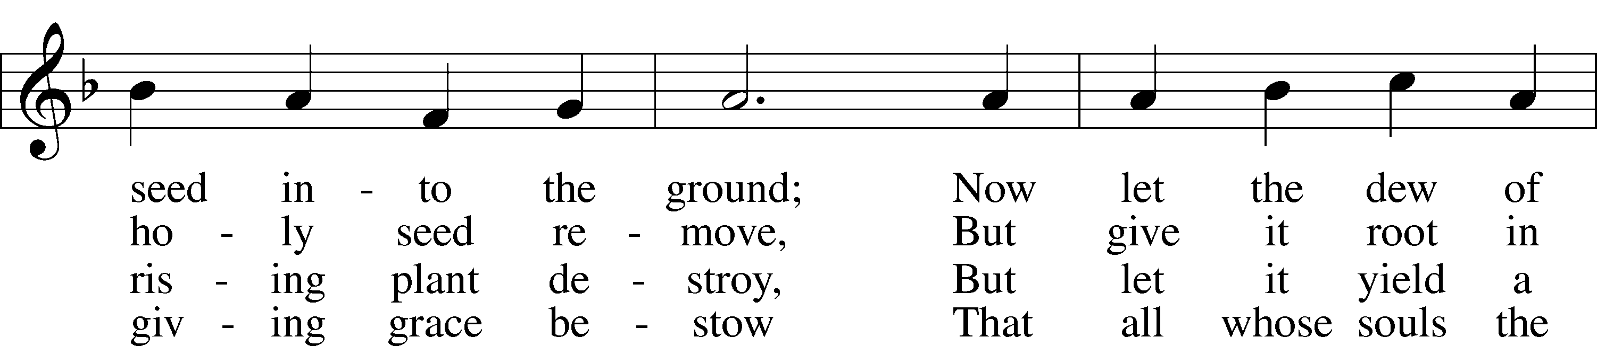
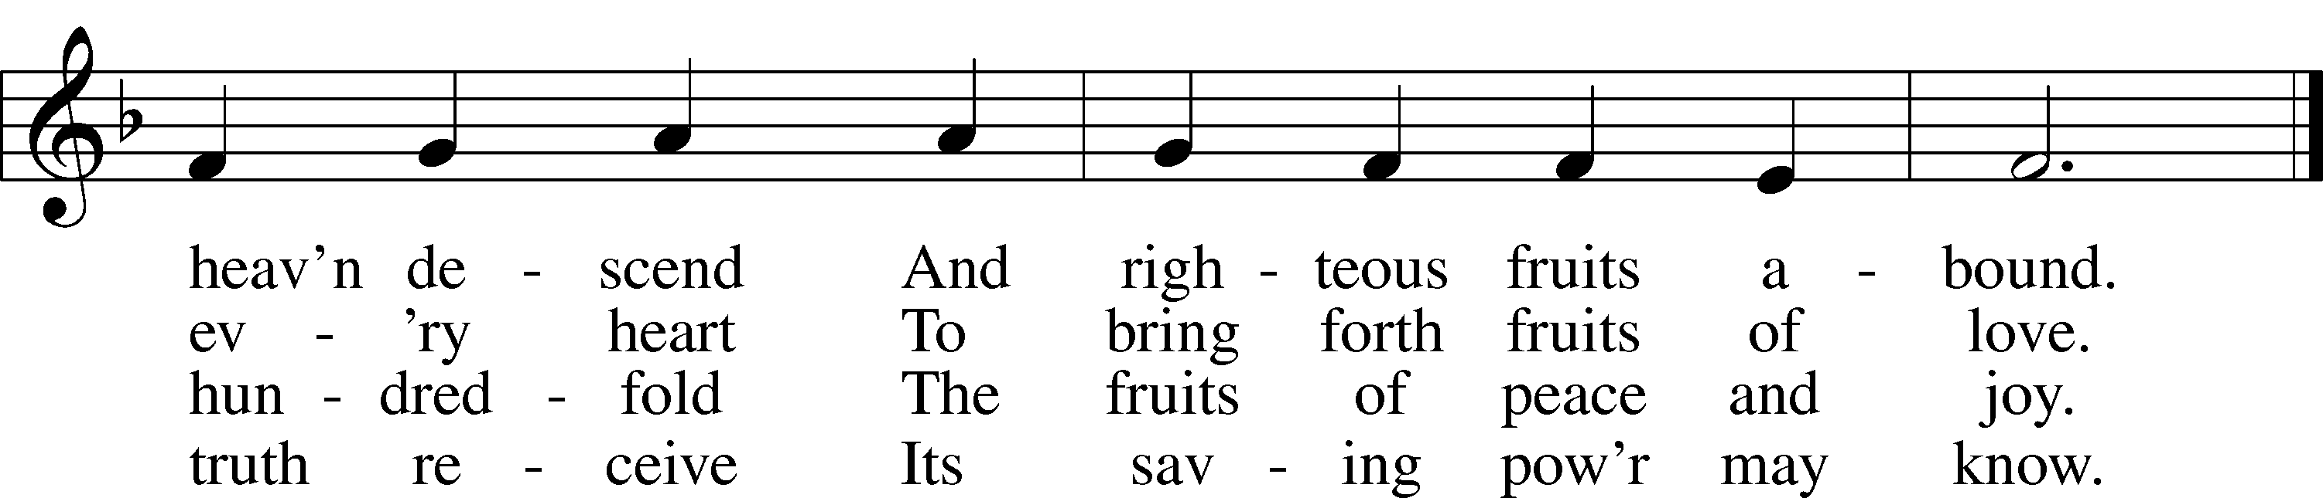

ANNOUNCEMENTS and SENDING WORDS
P We go to live for Jesus!
C We go to share His love!

Acknowledgments
Unless otherwise indicated, Scripture quotations are from the ESV® Bible (The Holy Bible, English Standard Version®), copyright 2001 by Crossway, a publishing ministry of Good News Publishers. Used by permission. All rights reserved. Created by Lutheran Service Builder. Music reproduced in this service is used with permission through: CCLI License No.1776588 and CPH – LSB Service Builder.

SERVING in GODS HOUSE TODAY
Pastor: Rev. Paul Schneider
Elder: Tom Raithel
Ushers: Terri Raithel, Ron Tesolin
Greeters: Ann & Ken Mertz
Coffee: Leslie Martin
Counters: Wendell Smith, Karl Scheiterlein
Altar Care: Karen Schneider
Virtual Organist: Bob Erat
Children’s Talk: Nancy Ely
Children’s Sunday School: Sharon Techel, Jean Beach and Nancy Ely
Sunday Morning Bible Study -With Dr. Tom Beach

PRAYERS
Please contact the office with updates to the prayer list. People will remain on the prayer list for 4 weeks before being removed. If they need to remain on the list, please keep Elaine informed and of any updates. This will help us to have a more accurate list. Thanks for your cooperation.
Those who continue to grieve the passing of loved ones: Family of Mary Lou Lochian Larry Whitneys Sister.
Those with upcoming surgery and medical procedure’s: Roger Raschke
Those recovering from surgery and medical procedure’s: Tanner Beyers, Roxy Mohr, Greg Techel, Joann Whitney, and Jim (Joann Whitney’s brother-in-law).
Those with health concerns: Tiffany Amsdill, Wally Beasinger, Ruth Bennett (Sharron Kato’s Sister), Jackie Bliss, Hope Buchinger, Betsy Cook, Paul Kietzman, Janice Knoellinger, Jennifer Martin, Eleanor Raether, Beth Smith, and Judi Stutzman.

Those diagnosed with cancer: Sue Cavanagh,Leah Eicher, Rachel Frisch, Janice Knoellinger, Leslie Martin, Brian Morgan, and Hope Osantowski.
Those under Hospice Home Care: Ken Williamson, Jim (Joann Whitney’s brother-in law).

BIRTHDAYS:
11/21 Donna Cottrell
11/22 Mazie Trahin
11/24 Renne Girard

11/24 Susan Straith
11/25 Molly Bartley
11/25 Jean Beach
11/25 Alan Tucek

ANNIVERSARY:
11/24 Tom & Joann Kraut
MESSAGES

ALTAR FLOWERS today are given to the glory of God from Ron & Gale Tesolin.
MEMBER & GUEST CARDS: If you have not filled out a member/guest card, please take the time to fill one out and place it in the plate behind the back pews in our sanctuary.
WEDNESDAY MORNING BIBLE STUDY, 10:00am in the fellowship hall with Pastor Ken Bernthal.
GREETING CARDS If you are in need of some greeting cards, we carry an array of them in the cabinet in the library. The cost of the cards is posted on the cabinet. The money collected from the cards goes to LWML to help support Missions.
CANCER and FRIENDS SUPPORT GROUP: We meet on the fourth Tuesday of each month at 5:30pm in the fellowship hall. Please remember Cancer & Friends Support Group is not just for people going through treatment, or survivors, we are also here for caregiver, spouse, children, and friends. There are times when we can all use someone to talk to during those difficult times. If there is any subject you would like to discuss with me you call or text or at 989-350-4391. Hope you will join us.
THANKSGIVING EVE SERVICE:We will be having a Thanksgiving Eve Service November 23rd at 7pm.
ANGEL TREE It's that time of year again. The Angel Christmas tree will be up in the Narthex it is adorned with Angels containing the names of children just waiting for you to go Christmas shopping for them. All you have to do is take the angel with a child’s name on it. When you return the gift (unwrapped) place it under the Angel tree. Gifts should be back by November 13th the latest is November 20th. Please, no food or candy. Thank you!
CONGREGATIONAL VOTERS MEETING: December Voters Meeting: Trinity’s Congregational Voters Meeting to elect officers and approve the 2023 church budget is expected to be held on Sunday, December 4th, following our worship service. The meeting will be held in our Fellowship Hall. We have several Council offices up for election, and we have a vacancy to fill for chairman of the Board of Stewardship. We are also seeking someone willing to relieve Mark Mohr as church treasurer, at his request. Please prayerfully consider whether your areas of giftedness could be used in service to our congregation by holding a Council board position. Please contact Bob Erat, 989-732-7153 if you would like more information. And plan to stay after service on December 4th for the Voter’s Meeting
COOKIE DECORATING & EXCHANGE: We will be doing cookie decorating on December 17th at noon. We will be trying to do a cookie exchange on the same day after the cookie painting. There sill be a sign up sheet on the shelf in the narthex. This will be sponsored by Outreach Board.

SERVING in GODS HOUSE NEXT SUNDAY NOVEMBER 27
Pastor: Rev. Paul Schneider
Elder: Gene Seibel
Ushers: John & Judi Stutzman
Greeters: Sharron Kato, Risa Sherman
Altar Care: Ann Mertz
Counters: Janet Arner, Kathy Erat
Coffee Servers: Elaine & Roger Raschke
Organist/Piano: Tom & Jean Beach
Children’s Talk: Nancy Ely
Children’s Sunday School: Sharon Techel, Jean Beach and Nancy Ely
Sunday Morning Bible Study: w/ Dr. Tom Beach 10:30am

THIS WEEK AT TRINITY
November 20 Sunday
9:00 am Worship Service -Rev. Ken Bernthal
10:00 am Fellowship & Coffee Hour
10: 10:30 am Sunday Morning Bible Study with Dr. Tom Beach
10:30 am Children’s Sunday School
November 21 Monday
10.00 am Kut-Ups
7:00 pm Choir
November 22 Tuesday
5:30 pm Cancer & Friends Support Group
November 23 Wednesday
10:00 am Wednesday Morning Bible Study W/ Pastor Ken Bernthal
7:00pm Thanksgiving Eve Service
November 24 Thursday
Happy Thanksgiving
November 25 Friday Secretary day off
November 26 Saturday
November 27 Sunday
9:00 am Worship Service -Rev. Ken Bernthal
Noisy Offering
10:00 am Fellowship & Coffee Hour
10: 10:30 am Sunday Morning Bible Study with Dr. Tom Beach
10:30 am Children’s Sunday School

A Blessed Thanksgiving

